Customer / Requester Journey Map
Requirement Analysis — ISTR Mission Request Journey Map

Date | 12/09/2026
Student Name | Navya Sri Tangellamudi
Project Name | Intergalactic Space Travel Request System (ISTR)
Phase | Phase 2 – Requirement Analysis

ISTR Mission Request Journey Map
A journey map lays out the full experience of the primary ISTR user — the Mission Requester — from the moment they become aware they need to submit a mission request, through submission and approvals, to launch and beyond. Mapping this journey surfaces the moments that matter most, the friction points worth solving, and concrete opportunities the ISTR system should address.
The journey is organized into five phases — Entice, Enter, Engage, Exit, and Extend — each broken into individual steps. For every step, the map captures what happens, who/what is involved, the requester's underlying goal, and where the experience feels positive, negative, or ripe for improvement.
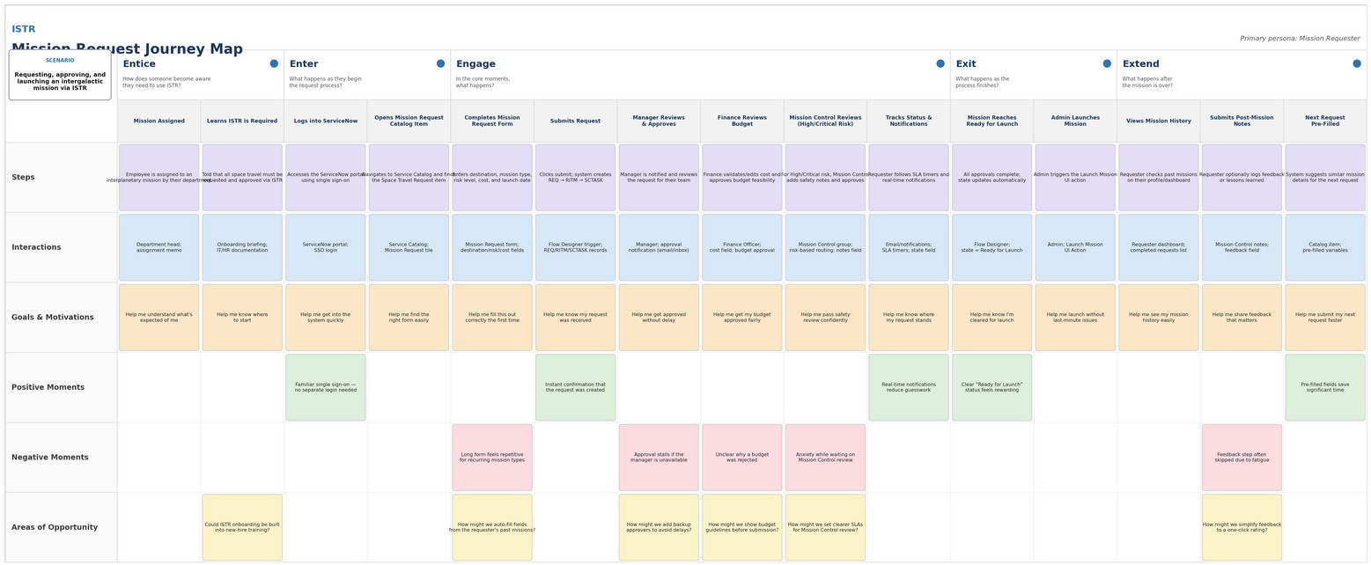
Primary Persona — The Mission Requester
Role: Scientist, Diplomat, or other mission-eligible staff member who needs to travel off-world for work.
Goal: Get a mission request submitted, approved, and launch-ready with minimal back-and-forth, and always know where it stands.
Frustration: Silence during approval — not knowing whether a manager, Finance, or Mission Control has even seen the request yet.

Figure 1 — ISTR Mission Request Journey Map (Entice → Enter → Engage → Exit → Extend)

Journey Sentiment by Phase
Plotting relative satisfaction across the five phases makes the friction concentration obvious: the Engage phase — where the request sits across Manager, Finance, and Mission Control approval — is the low point of the entire journey, while Exit (launch confirmation) is the emotional high point.

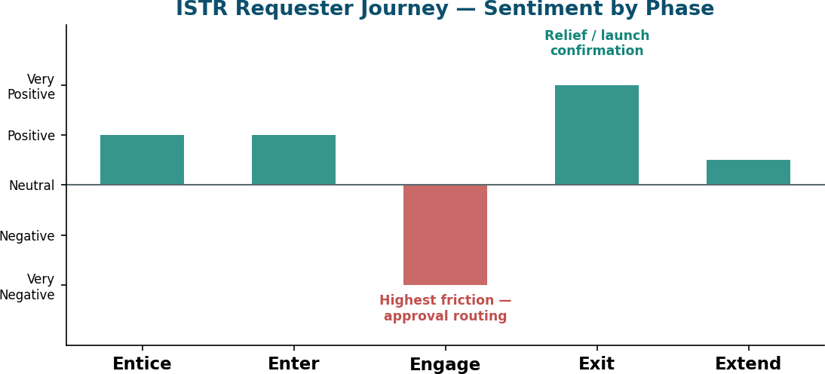

Figure 2 — Requester Sentiment Across Journey Phases

Key Takeaways from the Journey
- The Engage phase (form completion through Manager, Finance, and Mission Control approval) is the longest and highest-friction stretch of the journey — this is where ISTR's automation delivers the most value.
- Requesters consistently want visibility: knowing where a request stands is a recurring goal across nearly every step, reinforcing the need for SLA tracking and real-time notifications.
- Approval delays (unavailable managers, unclear budget rejections, uncertain Mission Control timelines) are the biggest negative moments — direct input for backup-approver and SLA-escalation design.
- The Extend phase highlights an opportunity ISTR does not yet fully capture: pre-filling future requests from mission history to reduce repetitive data entry.

Design Implications for ISTR
Each takeaway above maps directly onto a functional requirement carried into the Solution Requirements document, closing the loop between research and design:
- Engage-phase friction → FR-3 Approval Routing and FR-5 SLA & Escalation Management (auto-lookup routing, SLA timers, escalation reminders).
- Requester's need for visibility → FR-2 Request Confirmation and FR-7 Audit Trail & Reporting (status dashboard, in-app and email notifications).
- Uncertainty at Mission Control review → FR-3's conditional High/Critical-risk routing, giving the requester a clear, rule-based path instead of an opaque one.
- Extend-phase repetition → a candidate enhancement for a future release: pre-populating a new request from the requester's most recent completed mission.

